**Student Name: Weight: 20%**

**Student ID:** **Marks:** **/100**

# Assignment: Classes and Inheritance

## Scenario

A local company, Modern Appliances, has hired you to implement a system to manage their appliance data more efficiently. They want a system that allows both employees and customers to find, list and purchase appliances.

They company has provided you with a data file containing a sample list of appliances. The data file contains four types of appliances: refrigerators, vacuums, microwaves and dishwashers. Each appliance is uniquely identified using an item number, and information about each type of appliance is described in the formatting section.

## Equipment and Materials

For this assignment, you will need:

* Visual Studio IDE
* Supplied data file: **appliances.txt**

## Instructions

1. Review the scenario, and then carefully read the Appliance Details and Program Guidelines sections of this document.
2. Working outside of class time, complete the submission sections of this assignment.
3. Review the grading criteria for the group submissions.
4. See the course schedule and/or Brightspace for due dates.

**Submission**

Complete the partial class diagram provided in Figure 1 below so that it accurately represents the design of the program.

1. Create the code for a program that meets the requirements described below.
2. Test your code against the expected output provided.
3. Check your program against the detailed marking criteria at the end of this document.
4. Submit the following to Brightspace as a group (*Only one copy is required per group, and any of the group members may submit*):

* GitHub URL for your program code (invite your instructor to be a member of the project repository)
* A copy of the test output (.txt file)

**Peer Assessment (5%)**

Each student must also complete a peer assessment of their group members. Your instructor will provide further submission details.

## Appliance Details

#### Data Formatting

* Each of the following appliance types is represented differently in the supplied **appliances.txt** file.
* Each line in the file represents a different appliance and each piece of information for an appliance is separated by a semi-colon.
* The first digit of the Item Number indicates the type of the appliance. Each item number is 9 digits long.

**Refrigerators**

* The first digit of the Item Number for refrigerators is 1.
* Refrigerators have an Item Number, Brand, Quantity, Wattage, Color, Price, Number of Doors, Height and Width (in inches).
* The number of doors value can be either **2** (double doors), **3** (three doors) or **4** (four doors).
* Each refrigerator is represented in the appliances.txt file file as follows:

ItemNumber;Brand;Quantity;Wattage;Color;Price;NumberOfDoors;Height;Width

**Example:**

089360200;Bosch;176;60;black;2000;2;62;29;

**Vacuums**

* The first digit of the Item Number for vacuums is 2.
* Vacuums have an Item Number, Brand, Quantity, Wattage, Color, Price, Grade and Battery Voltage.
* The Battery voltage value can be either **18 V** (Low) or **24 V** (High).
* Each vacuum is represented in the appliances.txt file as follows:

ItemNumber;Brand;Quantity;Wattage;Color;Price;Grade;BatteryVoltage

**Example:**

263788832;Hoover;59;600;black;750;Residential;18;

**Microwaves**

* The first digit of the Item Number for microwaves is 3.
* Microwaves have an Item Number, Brand, Quantity, Wattage, Color, Price, Capacity and Room Type.
* The room type is where the microwave will be installed, and is either **K** (kitchen) or **W** (work site)
* Each microwave is represented in the appliances.txt file as follows:

ItemNumber;Brand;Quantity;Wattage;Color;Price;Capacity;RoomType

**Example:**

383477937;Miele;201;2350;white;179.9;1.8;Kitchen;

**Dishwashers**

* The first digit of the Item Number for dishwashers is 4 or 5.
* Dishwashers have an Item Number, Brand, Quantity, Wattage, Color, Price, Sound Rating, and Feature.
* The Sound Rating of the dishwasher can be Qt (Quietest), Qr (Quieter), Qu (Quiet) or M (Moderate).
* Each dishwasher is represented in the appliances.txt file as follows:

ItemNumber;Brand;Quantity;Wattage;Color;Price;Feature;SoundRating

**Example:**

587065284;Kenwood;74;1010;silver;390;Clean with Steam;Quiet;

## Program Guidelines

The fact that the data formatting is different for each type of appliance adds a level of complexity to program development. Creating a class hierarchy is required:

* Determine the attributes that are shared between the appliance types and create an **Appliance** class containing them.

**Note:** The **Appliance** class cannot be instantiated and must be a super-class.

* Create the following classes such that each one inherits the **Appliance** class and is located in the program’s **ProblemDomain** folder:
  + Refrigerator
  + Vacuum
  + Microwave
  + Dishwasher
* Ensure that each of these classes has a user-defined constructor that assigns the appropriate attributes.
* Override the *ToString()* method in each one of these classes, so that the data is in a human readable form.
* The attributes should be displayed using vertical headers.

Along with the functionality mentioned above, include the following methods in your program:

* A method that parses the **appliances.txt** file into a single list.
  + The list must be able to contain all appliance types (refrigerator, vacuum, microwave, and dishwasher).
  + Use the first digit of the item number to determine what valid type of appliance needs to be created (see the Appliance Details section for more information).
* A method that allows a customer to purchase an appliance.
  + The customer is prompted to enter the item number of an appliance. If the entered item number does not match, the program will inform the customer with an error message. If the item number matches, the program checks the appliance’s availability. If there is an appliance available, the available count will be decremented and the appliance information will be displayed. Otherwise, the customer will be informed the appliance is not available.
* A method that prompts the customer to enter a brand. The program performs a **case-insensitive search of appliances** that have the same brand, and displays them.
* A method that prompts a user to enter a number, and the program then displays that number of random appliances. The appliances can be of any type.
* When the program exits, implement and call a method that takes the appliances stored in the list and persists them back to the **appliances.txt** file in the proper format.

### Partial Class Diagram

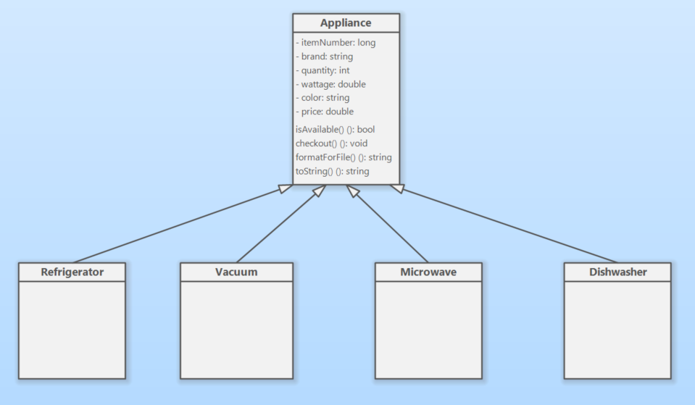

Figure 1: Partial Class Diagram

© 2022, Southern Alberta Institute of Technology

### Expected Output

Note: User inputs samples are **bold and underlined**.

Welcome to Modern Appliances!

How may we assist you?

1 – Check out appliance

2 – Find appliances by brand

3 – Display appliances by type

4 – Produce random appliance list

5 – Save & exit

Enter option:

**1**

Enter the item number of an appliance:

**255131796**

Appliance "255131796" has been checked out.

Welcome to Modern Appliances!

How May We Assist You?

1 – Check out appliance

2 – Find appliances by brand

3 – Display appliances by type

4 – Produce random appliance list

5 – Save & exit

Enter option:

**1**

Enter item number of an Appliance:

**143826003**

The appliance is not available to be checked out.

Welcome to Modern Appliances!

How May We Assist You?

1 – Check out appliance

2 – Find appliances by brand

3 – Display appliances by type

4 – Produce random appliance list

5 – Save & exit

Enter option:

**1**

Enter item number of an Appliance:

**1234567895**

No appliances found with that item number.

Welcome to Modern Appliances!

How May We Assist You?

1 – Check out appliance

2 – Find appliances by brand

3 – Display appliances by type

4 – Produce random appliance list

5 – Save & exit

Enter option:

**2**

Enter brand to search for:

**Tefal**

Matching Appliances:

ItemNumber: 535981394

Brand: Tefal

Quantity: 90

Wattage: 700

Color: bronze

Price: 320

Feature: Third Rack

SoundRating: Quietest

ItemNumber: 243074424

Brand: Tefal

Quantity: 61

Wattage: 4000

Color: black

Price: 760

Grade: Residential

BatteryVoltage: Low

Welcome to Modern Appliances!

How May We Assist You?

1 – Check out appliance

2 – Find appliances by brand

3 – Display appliances by type

4 – Produce random appliance list

5 – Save & exit

Enter option:

**3**

Appliance Types

1 – Refrigerators

2 – Vacuums

3 – Microwaves

4 – Dishwashers

Enter type of appliance:

**1**

Enter number of doors: 2 (double door), 3 (three doors) or 4 (four doors):

**3**

Matching refrigerators:

Item Number: 146947171

Brand: Black & Decker

Quantity: 112

Wattage: 1800

Color: grey

Price: 1800

Number of Doors: Three Doors

Height: 70

Width: 31

Item Number: 172911121

Brand: Philips

Quantity: 144

Wattage: 700

Color: black

Price: 3100

Number of Doors: Three Doors

Height: 71

Width: 30

Welcome to Modern Appliances!

How May We Assist You?

1 – Check out appliance

2 – Find appliances by brand

3 – Display appliances by type

4 – Produce random appliance list

5 – Save & exit

Enter option:

**3**

Appliance Types

1 – Refrigerators

2 – Vacuums

3 – Microwaves

4 – Dishwashers

Enter type of appliance:

**2**

Enter battery voltage value. 18 V (low) or 24 V (high)

**18**

Matching vacuums:

Item Number: 255131796

Brand: Black & Decker

Quantity: 54

Wattage: 1500

Color: white

Price: 500

Grade: Residential

Battery voltage: Low

Item Number: 263788832

Brand: Hoover

Quantity: 59

Wattage: 600

Color: black

Price: 750

Grade: Residential

Battery voltage: Low

Item Number: 231784690

Brand: Russell Hobbs

Quantity: 155

Wattage: 175

Color: grey

Price: 380

Grade: Residential

Battery voltage: Low

ItemNumber: 243074424

Brand: Tefal

Quantity: 61

Wattage: 4000

Color: black

Price: 760

Grade: Residential

Battery voltage: Low

Item Number: 240201796

Brand: Dyson

Quantity: 81

Wattage: 1050

Color: white

Price: 290

Grade: Residential

Battery voltage: Low

Welcome to Modern Appliances!

How May We Assist You?

1 – Check out appliance

2 – Find appliances by brand

3 – Display appliances by type

4 – Produce random appliance list

5 – Save & exit

Enter option:

**3**

Appliance Types

1 – Refrigerators

2 – Vacuums

3 – Microwaves

4 – Dishwashers

Enter type of appliance:

**3**

Room where the microwave will be installed: K (kitchen) or W (work site):

**W**

Matching microwaves:

Item Number: 328237584

Brand: Miele

Quantity: 90

Wattage: 1200

Color: bronze

Price: 250.23

Capacity: 2.1

Room Type: Work Site

Item Number: 333607621

Brand: Vax

Quantity: 113

Wattage: 440

Color: silver

Price: 123.99

Capacity: 1.6

Room Type: Work Site

Welcome to Modern Appliances!

How May We Assist You?

1 – Check out appliance

2 – Find appliances by brand

3 – Display appliances by type

4 – Produce random appliance list

5 – Save & exit

Enter option:

**3**

Appliance Types

1 – Refrigerators

2 – Vacuums

3 – Microwaves

4 – Dishwashers

Enter type of appliance:

**4**

Enter the sound rating of the dishwasher: Qt (Quietest), Qr (Quieter), Qu(Quiet) or M (Moderate):

**M**

Matching dishwashers:

Item Number: 571522655

Brand: Philips

Quantity: 228

Wattage: 440

Color: grey

Price: 390

Feature: Finger Print Resistant

SoundRating: Moderate

ItemNumber: 493374445

Brand: Philips

Quantity: 125

Wattage: 1650

Color: silver

Price: 510

Feature: Clean with Steam

SoundRating: Moderate

Welcome to Modern Appliances!

How May We Assist You?

1 – Check out appliance

2 – Find appliances by brand

3 – Display appliances by type

4 – Produce random appliance list

5 – Save & exit

Enter option:

**4**

Enter number of appliances:

**2**

Random appliances:

Item Number: 254565387

Brand: Miele

Quantity: 86

Wattage: 1000

Color: grey

Price: 800

Grade: Commercial

Battery Voltage: High

Item Number: 143826003

Brand: Kenwood

Quantity: 0

Wattage: 4700

Color: silver

Price: 1500

Number of Doors: Double Door

Height: 62

Width: 32

## Marking Criteria

### Peer assessment/Contribution list Submission

|  |  |  |  |
| --- | --- | --- | --- |
|  | **Not submitted (0%)** | **Submitted (100%)** | **Marks** |
| **Peer assessment** | * Not submitted | * Completed for the group member | **/5** |

### Group Submission

|  |  |  |  |  |
| --- | --- | --- | --- | --- |
|  | **Needs Improvement (0–50%)** | **Good (51–75%)** | **Excellent (76–100%)** | **Marks** |
| **Working Code - Output** | * The project doesn’t run in all scenarios * Input requests work but don’t match the scenario * Syntax errors * Output works but doesn’t match the scenario | * The project runs in all scenarios * Input requests work but don’t match the scenario * Correct use of inheritance * Output works but doesn’t match the scenario | * The project runs in all scenarios * Input requests match the scenario exactly * Inheritance correctly used * Output matches the scenario | **10** |
| **Working Code – Validation and List** | * Validate appliance types information doesn’t work * Fill List with class items doesn’t work | * Validate appliance types information doesn’t work correctly * Fill List with class items doesn’t work correctly | * Validate appliance types information works correctly * Fill List with class items works correctly | **10** |
| **Working Code – Appliance check out** | * Using item number to populate the list doesn’t work * Check out an appliance doesn’t work | * Checkout an appliance * Use item number to populate the List doesn’t work correctly | * Check out an appliance works correctly * Using item number to populate the list works correctly | **10** |
| **Working code – Finding appliances** | * Finding appliances with a specific brand doesn’t work | * Find appliances with specific brand | * Finding appliances with a specific brand works correctly | **9** |
| **Working code – Displaying Appliances** | * Displaying appliances of a specific type doesn’t work | * Display appliances with a specific type | * Displaying appliances of a specific type works correctly | **9** |
| **Working Code – Random list of Appliances** | * Producing a list of random appliances doesn’t work | * Produce a list of random appliances | * A list of random appliances is produced correctly | **9** |
| **Working Code - Persist** | * Persist changes to data file doesn’t work | * Persist changes to data file doesn’t work correctly | * Persist changes to data file works correctly | **9** |
| **Working Code – Override method** | * Override toString method in each inherited class doesn’t work | * Override toString method in each inherited class | * Override toString method in each inherited class works correctly | **9** |
| **Style** | * Indentation – not consistent * Readability – poor variable names * Documentation: * No comments are included at the top. * No comments indicating major code sections or what they do | * Indentation – some parts are consistent and some are not * Readability – some variable names are not ideal * Documentation: * Comments at the top are missing or incomplete. * Comments indicating major code sections and what they do are incomplete | * Indentation – consistent * Readability – good variable names * Documentation: * Comments at the top are complete and include name, date, program description including details on inputs, processing and outputs  (4–5 sentences minimum). * Comments indicate major code sections and what they do | **/10** |
| **Testing** | * Sample output doesn’t match the provided expected output * Output is not formatted according to the specification (expected output) | * Parts of the sample output don’t exactly match the expected output * Output formatted according to the specification (expected output) | * Sample output exactly matches the provided expected output * Output formatted according to the specification (expected output) | **/10** |
| **Total** | | | | **/100** |